HR Retention Analytics Project – Alpha Manufacturing Solutions
Meridian People Analytics Consulting

Attrition Rate by Tenure
The tenure analysis reveals a significant variation in attrition risk depending on how long employees have been with the company. Employees with 0–2 years of tenure show a very low attrition rate of approximately **0.0200 (2%)**, indicating that new employees are generally retained successfully during their initial onboarding period.
However, attrition increases dramatically for employees with **3–5 years of tenure**, where the attrition rate rises to approximately **0.3150 (31.5%)**. This represents the highest turnover segment in the workforce and suggests that mid‑career employees may be leaving due to limited advancement opportunities, compensation concerns, or external job opportunities.
For employees with **6–10 years of tenure**, attrition declines to approximately **0.1650 (16.5%)**. While this is significantly lower than the mid‑tenure group, it still indicates meaningful turnover among experienced employees.
From a consulting perspective, the data suggests that **the 3–5 year employee segment is the highest risk population** and should be prioritized for retention initiatives such as promotion opportunities, leadership development programs, and compensation benchmarking.
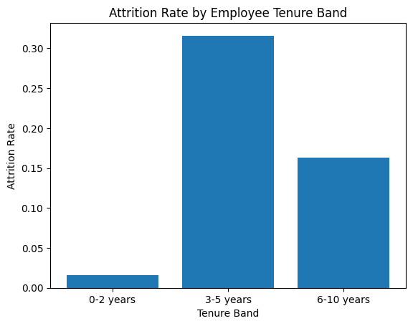

Workforce Distribution by Tenure
The workforce distribution chart shows that the majority of employees fall within the **3–5 year tenure band**, with approximately **10,500 employees** in this group. In comparison, there are approximately **3,200 employees** in the **0–2 year group** and about **1,300 employees** in the **6–10 year group**.
This distribution indicates that the organization experienced a major hiring wave roughly three to five years ago, resulting in a large concentration of employees in that tenure band.
When combined with the attrition findings from the previous chart, this distribution is particularly concerning. Since the **largest workforce segment also has the highest attrition rate**, the organization is at risk of losing a substantial portion of its workforce if retention issues are not addressed.
From a workforce planning perspective, losing even **10–15% of the 3–5 year group could represent over 1,000 employees**, creating major operational disruptions and recruitment costs.
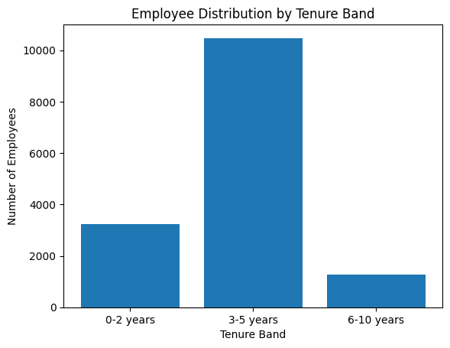

Attrition by Tenure and Promotion Status
Promotion history plays a significant role in employee retention. Among employees who **did not receive a promotion**, attrition rates mirror the earlier tenure findings, with approximately **0.0200 (2%) attrition in the 0–2 year group**, rising sharply to **0.3200 (32%) in the 3–5 year group**, and settling near **0.1750 (17.5%) in the 6–10 year group**.
In contrast, employees who **received a promotion within the past five years show dramatically lower attrition levels**. Attrition among promoted employees remains close to **0.0000 (0%) in the 0–2 and 6–10 year groups**, and only around **0.1000 (10%) for employees in the 3–5 year band**.
This difference demonstrates the powerful role that **career progression plays in retaining employees**. Employees who see advancement opportunities are far more likely to remain with the organization.
From a consulting perspective, this finding strongly supports implementing **structured promotion pathways and internal mobility programs**, particularly for employees approaching the 3–5 year tenure milestone.
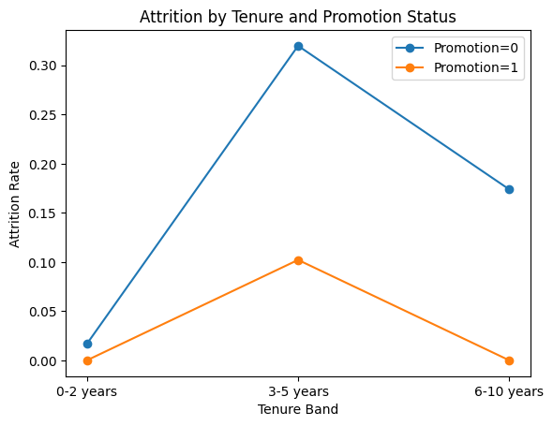

Attrition Rate by Employee Satisfaction Level
Employee satisfaction exhibits one of the strongest relationships with attrition. Employees in the **lowest satisfaction bins show extremely high attrition levels**, with rates around **0.5100 (51%) and 0.6700 (67%)** for the two lowest satisfaction groups.
In contrast, employees with **moderate satisfaction levels experience dramatically lower attrition of approximately 0.0500 (5%)**, representing the lowest attrition segment in the analysis.
Interestingly, attrition increases slightly again for higher satisfaction bins, reaching roughly **0.1200–0.1300 (12–13%)**, although these rates remain far lower than the lowest satisfaction groups.
This pattern suggests that **employee dissatisfaction is one of the primary drivers of turnover**, particularly among disengaged employees. Organizations should closely monitor engagement surveys and identify departments or managers associated with consistently low satisfaction scores.
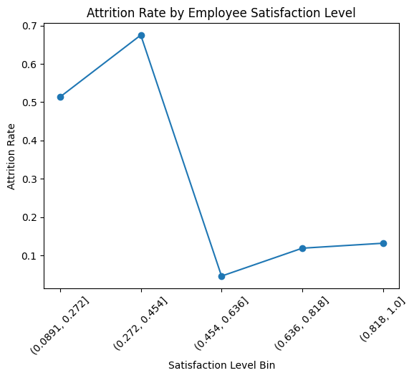

Attrition Rate by Workload (Average Monthly Hours)
Workload analysis shows a clear nonlinear relationship between working hours and attrition risk. Employees working **95–132 hours per month experience attrition around 0.2900 (29%)**, while those working **132–167 hours show attrition near 0.3300 (33%)**.
Interestingly, attrition drops dramatically to approximately **0.0200 (2%)** for employees working **167–203 hours per month**, suggesting that this range may represent an optimal workload level where employees remain engaged but not overworked.
Attrition begins to rise again as workload increases beyond this range, reaching approximately **0.2700 (27%)** for employees working **238–274 hours**, and peaking at **0.7200 (72%)** for those exceeding **274 hours per month**.
These findings strongly suggest that **extreme workloads lead to burnout and significantly increase turnover risk**.
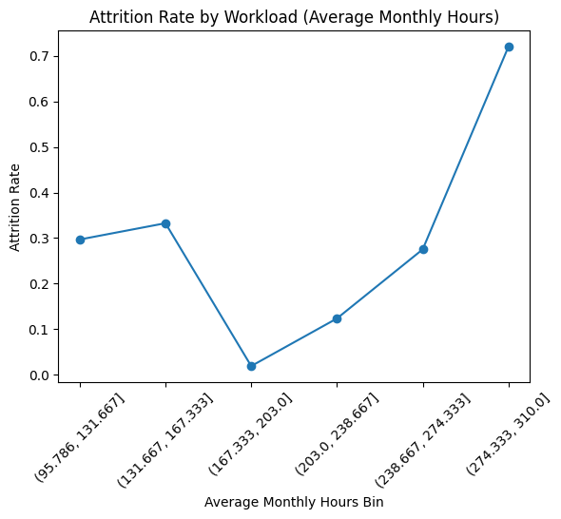

Attrition Rate by Number of Projects
The number of projects assigned to employees shows a strong U‑shaped relationship with attrition. Employees assigned **two projects show attrition near 0.6500 (65%)**, indicating underutilization or disengagement.
Attrition drops dramatically to approximately **0.0200 (2%) for employees with three projects**, representing the most stable workload level.
Attrition begins increasing again as the number of projects rises, reaching approximately **0.0900 (9%) for four projects**, **0.2200 (22%) for five projects**, and **0.5600 (56%) for six projects**.
Employees handling **seven projects show nearly 1.0000 (100%) attrition**, indicating extreme overload.
From a workforce management perspective, the optimal project allocation appears to be **three to four projects per employee**, where attrition risk is lowest.
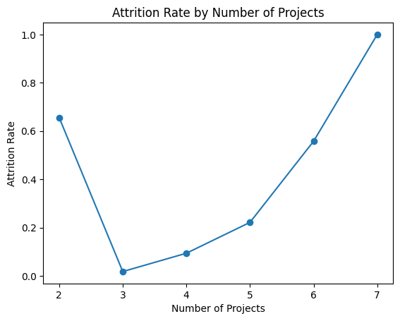

Attrition Heatmap by Tenure
The attrition heatmap provides a condensed visual representation of attrition rates across tenure groups. The heatmap clearly highlights the **3–5 year tenure band as the highest attrition segment**, corresponding to approximately **31.5% attrition**.
In contrast, the **0–2 year group shows minimal attrition near 2%**, while the **6–10 year group falls in the middle with roughly 16–17% attrition**.
The visualization reinforces the key conclusion of the analysis: **mid‑tenure employees represent the most vulnerable group within the workforce**.
From a strategic HR perspective, this insight suggests that organizations should focus retention strategies on employees approaching their **third to fifth year**, including promotion opportunities, leadership development, and compensation reviews.
